Ashleworth Parish Council  Clerk: Nicky Hill  Orchard Cottage  Hill Farm Lane  Tirley  GL194EZ  Tel: 01452 781028 Email:ashleworthpc@gmail.com | 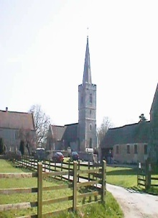

Minutes of the Meeting of 8th June 2021
This meeting was held outside of the Post Office

Councillors Present | In attendance
Tony Eardley (TE) Chairman | Clerk: Nicky Hill (NH)
Paul Finch (PF) Vice Chairman
Aly Shayle (AS)
Grant Elliott (GE)
James Joyce (JJ)

923/0621 | TE welcomed everyone to the meeting explained that this meeting had been called as a single-issue meeting to predominantly formalize the handover of the Play area project from JJ to GE & AS
924/0621 | Apologies for absence.  None received.
925/0621 | Declaration of Interests.  None received.
926/0621 | Playground Area lead handover and discussions.  GE & AS have agreed to take over the Play area project from JJ  GE handed out an informal agenda discussion list that itemised the start of gathering information. The early findings highlighted the need for:  - Location  - Size  - Target ages  - Funding alongside section 106  - Planning Permission  - Engagement with community  - Multi ability  - Old playground  - Timescales  The project will be discussed with the Woodies to firstly determine location and size. TE will action along with proposals regarding a revised and replacement lease between APC and the Woodies.  It was suggested that public consultation and advertising should be priority at this stage.  TE will contact the Woodies to arrange views on engaging interest in the project, possibly to coincide with their Open Day.  GE will action FB and WoSN advertising.  AS will contact school for consultation and views.  AS suggested a working group with various village community groups. AS & GE agreed to represent APC.
927/0621 | To confirm date of next meeting as Tuesday 13th July 2021– Agreed
 | Meeting closed at 9.10pm

