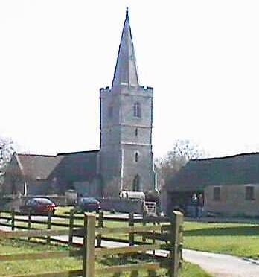

Asset Register
Reviewed May 2023
ASHLEWORTH PARISH COUNCIL

Tel: 01452 781028

Email: ashleworthpc@gmail.com

Asset Register - May 2023

Item | Date Acquired | Location | Restrictions | Purchase price | Value at 2023
Bus Shelter | Feb 2009 | Nup End | n/a |  | £5000
Play Equipment | May 2000 | Woodpeckers Playing Field | n/a |  | £2250
Bench | unknown | Village Green | n/a |  | £50
Bench donated by WI | 2011 | Village Green | n/a |  | £800
Notice Board | unknown | Bus shelter | n/a |  | £30
Village Green | 1959 | GL19 | Conservation area, public land |  | £1
Car Park | August 1990 | Nupp End | No building allowed |  | £2000
Ashleworth Sports Ground | May 1995 | Foscombe Lane | No building allowed |  | £1100
Ashleworth village signs | n/a | Broad Street, Lawn Road and Stonebow. | n/a |  | £620
Defibrillator and Cabinet | March 2016 | Post Office | n/a | £1301 | £1301
Village Green posts | November 2017 | Village Green | n/a | 954 | £954
Phone Box | March 2017 | Near Post Office | n/a | £1 | Reviewed replacement value  £5000
Waste bin | August 2018 | Village Green | n/a | £447.64 | £448
Dog waste bin | August 2018 | Woopeckers | n/a | No charge from TBC | £250
Notice Board | September 2018 | Bus shelter | n/a | £231.47 | £232
USB sticks | September 2018 | Clerk/Chairman | n/a | £44.97 | £45
2 drawer metal filing cabinet |  | Clerks home office | n/a |  | £20
Dog waste bin | January 2020 | Rectory Close | n/a | S106 Funds TBC | 250
Millennium plaque |  | Nup End next to bus shelter | n/a |  | £450
Dog waste bin | Feb 2023 | Wickridge Street | n/a | £349 | £349
 |  |  |  | Total Value | £21,150

